MODUL 2: AUTENTIKASI ADMIN & CRUD MASTER MAKANAN
1. Instal Laravel Breeze via Composer:
composer require laravel/breeze --dev
2. Jalankan Perintah Instalasi Breeze:
php artisan breeze:install
-- pilih: blade
-- dark mode?: NO
-- framework do you prefer?: 0 (PHPUnit)
Langkah Wajib Setelah Instalasi Selesai:
Setelah generator Breeze selesai, jalankan perintah ini secara berurutan di terminal:
php artisan migrate
php artisan storage:link
npm install
npm run build
3. Isi File app/Http/Controllers/FoodController.php
Buka file FoodController.php dan ganti kodenya menjadi seperti di bawah ini:

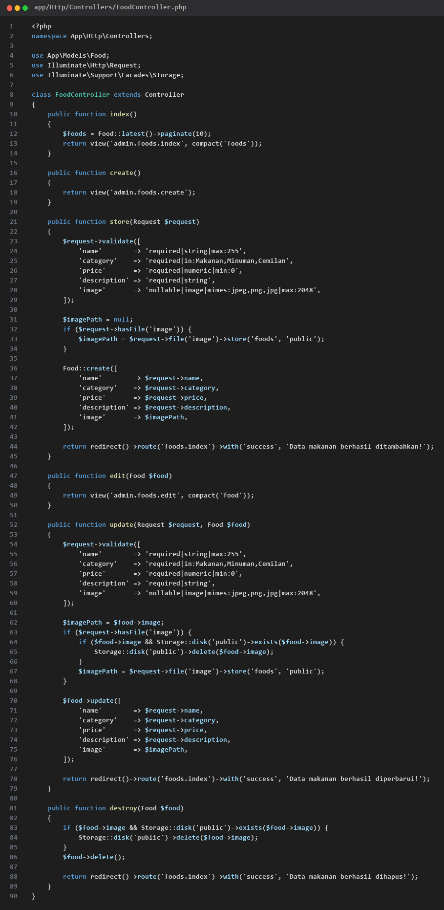
app/Http/Controllers/FoodController.php
4. Tampilan CRUD Admin
Buat folder baru di resources/views/admin/foods/, lalu buat 3 file Blade berikut:
resources/views/admin/foods/index.blade.php (Daftar Makanan):
<x-app-layout>
<x-slot name="header">
<h2 class="font-semibold text-xl text-gray-800 leading-tight">Master Data Makanan</h2>
</x-slot>
<div class="py-12 max-w-7xl mx-auto sm:px-6 lg:px-8">
<a href="{{ route('foods.create') }}" class="bg-blue-600 hover:bg-blue-700 text-white px-4 py-2 rounded mb-4 inline-block font-semibold">+ Tambah Makanan</a>
@if(session('success'))
<div class="bg-green-100 border border-green-400 text-green-700 p-3 rounded mb-4">{{ session('success') }}</div>
@endif
<table class="w-full bg-white border mt-4 shadow-sm rounded-lg overflow-hidden">
<thead>
<tr class="bg-gray-100 border-b text-gray-600 text-sm">
<th class="p-3">Gambar</th>
<th class="p-3">Nama</th>
<th class="p-3">Kategori</th>
<th class="p-3">Harga</th>
<th class="p-3">Aksi</th>
</tr>
</thead>
<tbody>
@foreach($foods as $food)
<tr class="border-b text-center text-sm">
<td class="p-3">
@if($food->image)
<img src="{{ asset('storage/' . $food->image) }}" class="w-16 h-16 object-cover mx-auto rounded">
@else
<span class="text-gray-400 text-xs">No Image</span>
@endif
</td>
<td class="p-3 font-semibold">{{ $food->name }}</td>
<td class="p-3">{{ $food->category }}</td>
<td class="p-3 font-bold text-green-600">Rp {{ number_format($food->price) }}</td>
<td class="p-3">
<a href="{{ route('foods.edit', $food->id) }}" class="text-blue-600 hover:underline mr-3 font-semibold">Edit</a>
<form action="{{ route('foods.destroy', $food->id) }}" method="POST" class="inline">
@csrf
@method('DELETE')
<button type="submit" onclick="return confirm('Yakin hapus data ini?')" class="text-red-600 hover:underline font-semibold">Hapus</button>
</form>
</td>
</tr>
@endforeach
</tbody>
</table>
<div class="mt-4">{{ $foods->links() }}</div>
</div>
</x-app-layout>

resources/views/admin/foods/create.blade.php (Tambah Makanan):
<x-app-layout>
<x-slot name="header">
<h2 class="font-semibold text-xl text-gray-800 leading-tight">Tambah Makanan</h2>
</x-slot>
<div class="py-12 max-w-2xl mx-auto sm:px-6 lg:px-8">
<form action="{{ route('foods.store') }}" method="POST" enctype="multipart/form-data" class="bg-white p-6 rounded-lg shadow-sm border">
@csrf
<div class="mb-4">
<label class="block font-medium mb-1">Nama Makanan</label>
<input type="text" name="name" class="w-full border rounded p-2" required>
</div>
<div class="mb-4">
<label class="block font-medium mb-1">Kategori</label>
<select name="category" class="w-full border rounded p-2" required>
<option value="Makanan">Makanan</option>
<option value="Minuman">Minuman</option>
<option value="Cemilan">Cemilan</option>
</select>
</div>
<div class="mb-4">
<label class="block font-medium mb-1">Harga (Rp)</label>
<input type="number" name="price" class="w-full border rounded p-2" required>
</div>
<div class="mb-4">
<label class="block font-medium mb-1">Deskripsi</label>
<textarea name="description" class="w-full border rounded p-2" rows="3" required></textarea>
</div>
<div class="mb-4">
<label class="block font-medium mb-1">Gambar Makanan</label>
<input type="file" name="image" class="w-full border rounded p-2">
</div>
<button type="submit" class="bg-green-600 hover:bg-green-700 text-white px-6 py-2.5 rounded font-semibold">Simpan Data</button>
</form>
</div>
</x-app-layout>

resources/views/admin/foods/edit.blade.php (Edit Makanan):
<x-app-layout>
<x-slot name="header">
<h2 class="font-semibold text-xl text-gray-800 leading-tight">Edit Makanan</h2>
</x-slot>
<div class="py-12 max-w-2xl mx-auto sm:px-6 lg:px-8">
<form action="{{ route('foods.update', $food->id) }}" method="POST" enctype="multipart/form-data" class="bg-white p-6 rounded-lg shadow-sm border">
@csrf
@method('PUT')
<div class="mb-4">
<label class="block font-medium mb-1">Nama Makanan</label>
<input type="text" name="name" value="{{ $food->name }}" class="w-full border rounded p-2" required>
</div>
<div class="mb-4">
<label class="block font-medium mb-1">Kategori</label>
<select name="category" class="w-full border rounded p-2" required>
<option value="Makanan" {{ $food->category == 'Makanan' ? 'selected' : '' }}>Makanan</option>
<option value="Minuman" {{ $food->category == 'Minuman' ? 'selected' : '' }}>Minuman</option>
<option value="Cemilan" {{ $food->category == 'Cemilan' ? 'selected' : '' }}>Cemilan</option>
</select>
</div>
<div class="mb-4">
<label class="block font-medium mb-1">Harga (Rp)</label>
<input type="number" name="price" value="{{ $food->price }}" class="w-full border rounded p-2" required>
</div>
<div class="mb-4">
<label class="block font-medium mb-1">Deskripsi</label>
<textarea name="description" class="w-full border rounded p-2" rows="3" required>{{ $food->description }}</textarea>
</div>
<div class="mb-4">
<label class="block font-medium mb-1">Gambar Baru (Opsional)</label>
<input type="file" name="image" class="w-full border rounded p-2">
</div>
<button type="submit" class="bg-blue-600 hover:bg-blue-700 text-white px-6 py-2.5 rounded font-semibold">Update Data</button>
</form>
</div>
</x-app-layout>

